City Semester 13-14 Ms. Nelson

# PROBLEM SET 2-3: Curve Fitting with Data Sets - Solution

1. 🖳 Revisit “Average Hourly Wage” in NYC 2009 to 2013

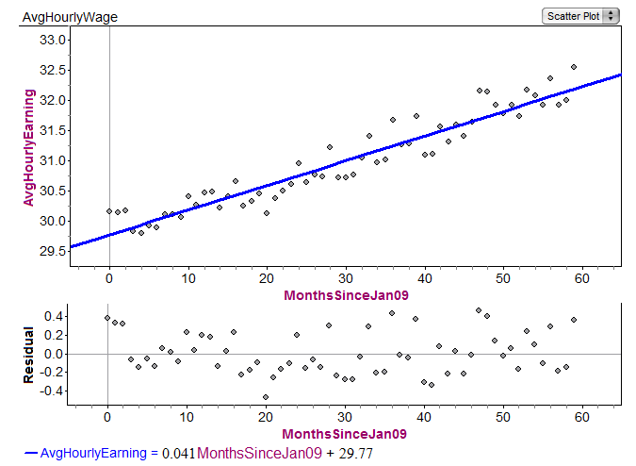

* 1. Open data file “AvgHourlyEarnings-NYC” and fully “analyze the data” according to the 5 steps shown on the slides (you can use your model from the last problem set if you still have it).
  2. Write a sentence that explains the meaning of the slope of your linear model within the context.

**Slope of my model is about 0.04, meaning each additional month since Jan 09 NYC workers’ average hourly earnings have gone up by about 4 cents.**

* 1. Use the model to predict what the Average Hourly Wage would be for Jan 2015 (72 months after Jan ’09) **$32.72**
  2. According to the slope of the model, what was the average **yearly** change in hourly wage?

**0.041 * 12 = 0.492 – so average hourly earning is going up about 50 cents a year**

1. 🖳 We know that the weather tends to be cold in January, warm up through summer then get cold again at the end of the year. Is that a parabolic shape?

Open the Fathom File “NYCAvgDailyTemp” and “analyze the data” according to the 5 steps.

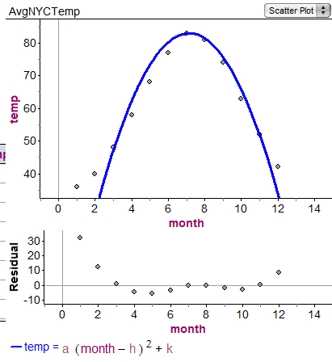**a = -2.09, h=7.14, k=83.0**

**There is a clear pattern to the residuals here (kind of W shaped), which tells us that a quadratic is not an appropriate modeling function for this data. However, between the months of March to November, it’s decently useful.**

1. 🖳 Since the beginning of the industrial revolution there has been an ever increasing of concentration of carbon dioxide (CO2) in our atmosphere. CO2 in our atmosphere results in the greenhouse effect which has lead to global warming. CO2 concentration is usually measured in parts per million by volume (ppmv). Just prior to the industrial revolution CO2 concentrations were about 280 ppmv. By 2008 CO2 concentrations reached about 385 ppmv (safe is considered ≤ 350). There is a growing consensus among scientists that specialize in global warming that 450 ppmv is a threshold above which disastrous , irrevocable changes would happen to the planet.
   1. Open up the Fathom file “CO2 Annual 2000-2007” and “analyze the data”.
   2. Write a sentence that explains the meaning of the slope of the linear model within the context.
   3. According to your model, in what year will CO2 concentration reach 450 ppmv?

